Build Requirements:

Tools:

* Visual Studio 2008 Professional
* Windows 7 WDK 7600.16385.0 or later, 7600.16385.1 is better
* Windows SDK v6.0A or later, v7.1 is better

Notes:

* Need to install Visual Studio 2008 SP1 package firstly before building.
* Set $(WindowsSdkDir) and $(FrameworkSDKDir) to both refer to Windows 7 SDK.
  + - Install the SDK from Microsoft.
    - Navigate to *<Install Directory>\Setup* folder. Default is similar to “C:\Program Files\Microsoft SDKs\Windows\v7.1\Setup”
    - Run WindowsSdkVer.exe
    - Select latest version in drop-down menu and click *Make Current*.

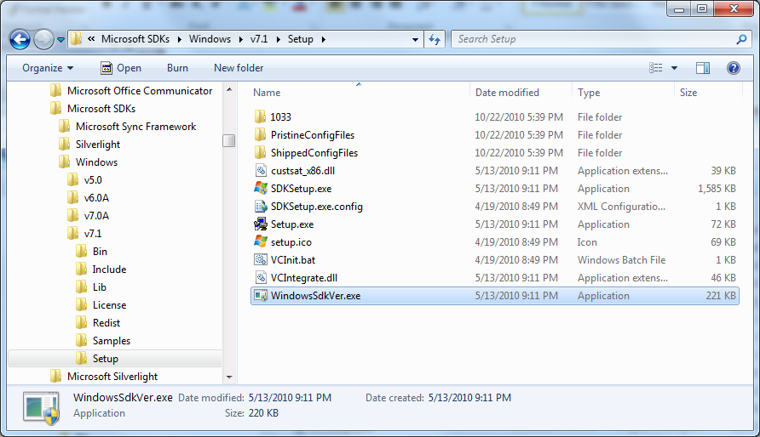

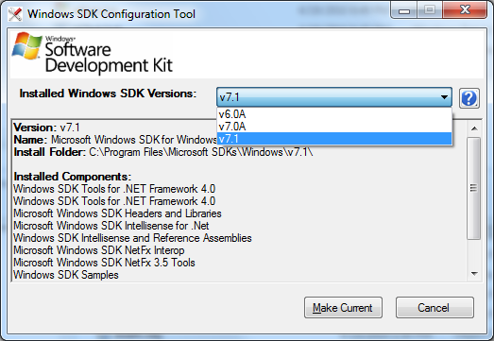

* Set Additional Include Directories for Mfgtool_MultiPanel.
  + - In VS2008 Solution Explorer, right-click MfgToolLib project and select *Properties*.
    - Select *Configuration Properties -> C/C++ -> General*.
    - Select *Additional Include Directories*.
    - Click the … button in the *Additional Include Directories* edit box.

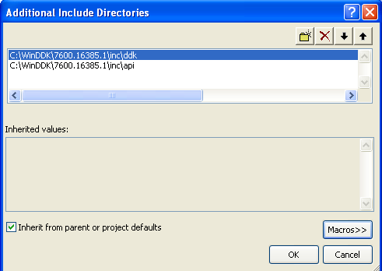

* Because of the define conflict between SDK and DDK, we may need to remove the sal.h file from DDK inc path to avoid the build errors;
  + - Change the sal.h to another name like sah1.h
    - The sal.h file can be found @DDK install path like D:\WinDDK\7600.16385.0\inc\api
    - Restore the sal.h file if you don’t need to build MFGTool binary any more.
* Double click Apps\MfgTool.exe\MfgTool.2008.sln or open Project/Solution in VS2008 and then select MfgTool.2008.sln in Apps\MfgTool.exe\ to open the project and in Build -> Rebuild Solution to build the project.